Lecture 5 Arbitrage and Speculation

2022-08-09T05:54:59.000Z

Learning Objectives

* To discuss the consequences when *international parity conditions are violated*
* To analyze the process of **covered interest arbitrage**
* To examine how foreign currency **swaps** are used by investors and borrowers
* To consider the role of **speculators** in spot and forward markets

## 1. Arbitrage and Speculation

Speculators and arbitrageurs **seek to profit** from trading in the market.

* They operate for their **own interest, without need or obligation** to serve clients or ensure a continuous market.
* A large proportion of speculation and arbitrage is conducted **on behalf of major banks** by dealers employed by those banks.

Arbitrage Transactions

* An arbitrageur takes advantage of opportunities for profit which arise from short-term price discrepancies between different markets
* There is no risk - buy and sell at the same time
* Arbitrage actions eliminate the price differentials

Speculative Transactions

* Speculators aim to make a profit by buying at a low price and selling at a higher price
* Entails risk since expectations may not be fulfilled
* ‘Short’ - sell before buying if expect asset price to fall
* ‘Long’ - buy prior to selling if expect asset price to rise

**Summary**:

|  |  |  |
| --- | --- | --- |
|  | Arbitrage | Speculation |
| Risk | No | Yes |
| Profit | Short-term price discrepancies in between different markets | Buying at a low price and selling at a higher price |
| Strategy | Buy and sell at the same time | Short or long |

## 2. Foreign Currency Arbitrage

### 2.1 Covered Interest Arbitrage

Capital flow:

$$i^{DC}=i^{\text{FC}}+\text{Forward Magin}$$

To calculate the forward rate

$$F_{n}^{\text{FX/\$}}=S^{\text{FX/\$}}×\frac{\left[1+\left(i^{\text{FX}}×\frac{n}{360}\right)\right]}{\left[1+\left(i^{\$}×\frac{n}{360}\right)\right]}$$

**Practice** (Semester 2 – Mid, 2019)

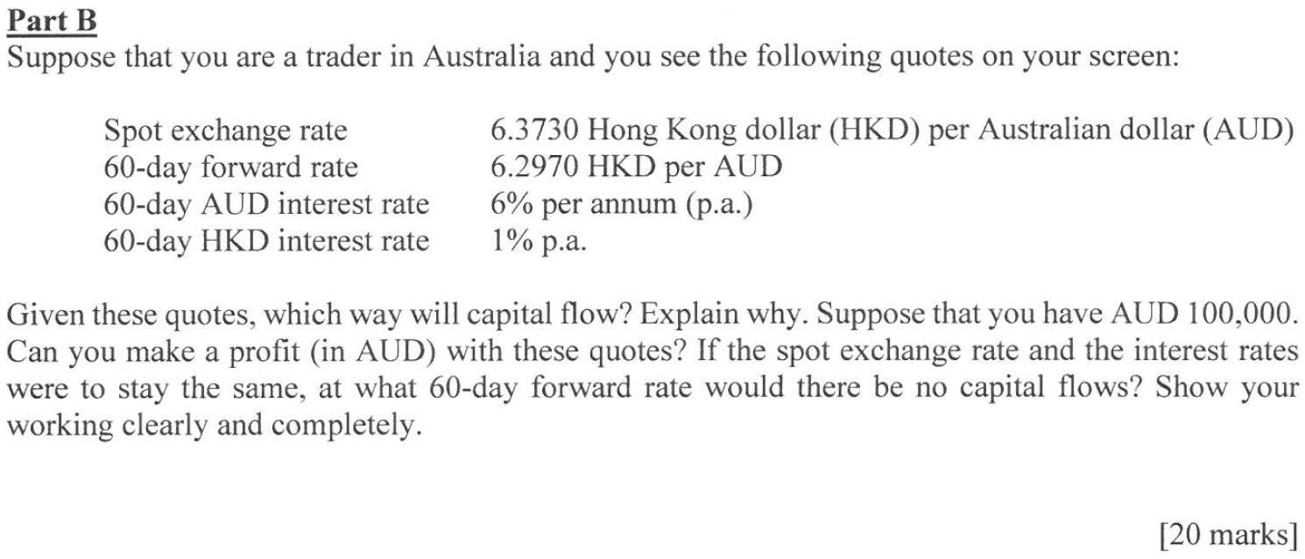

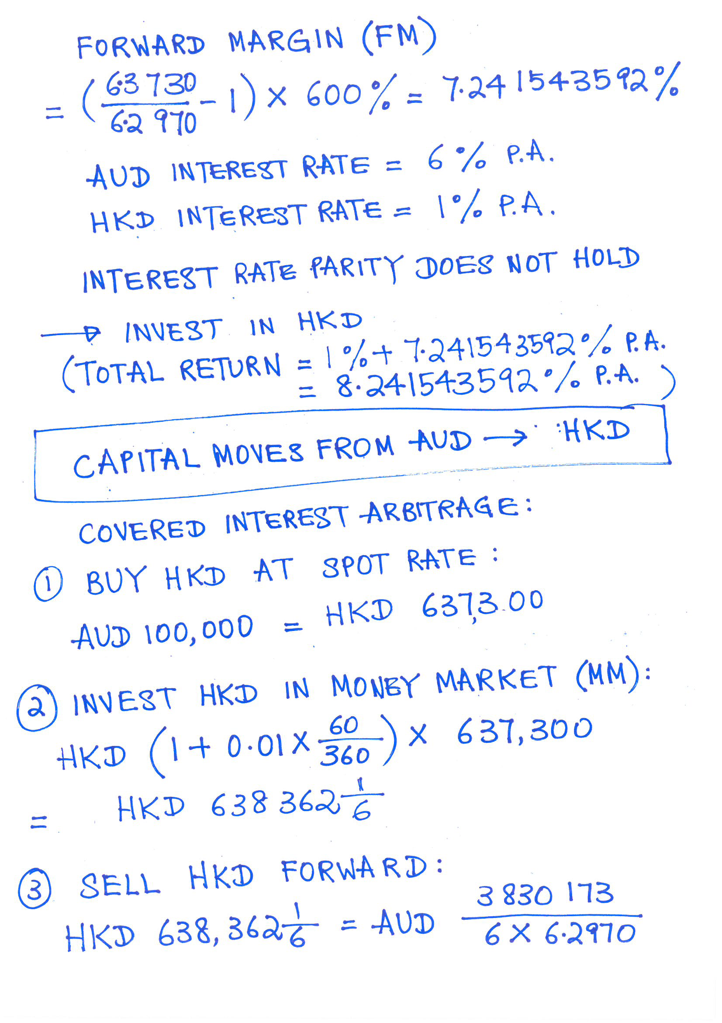

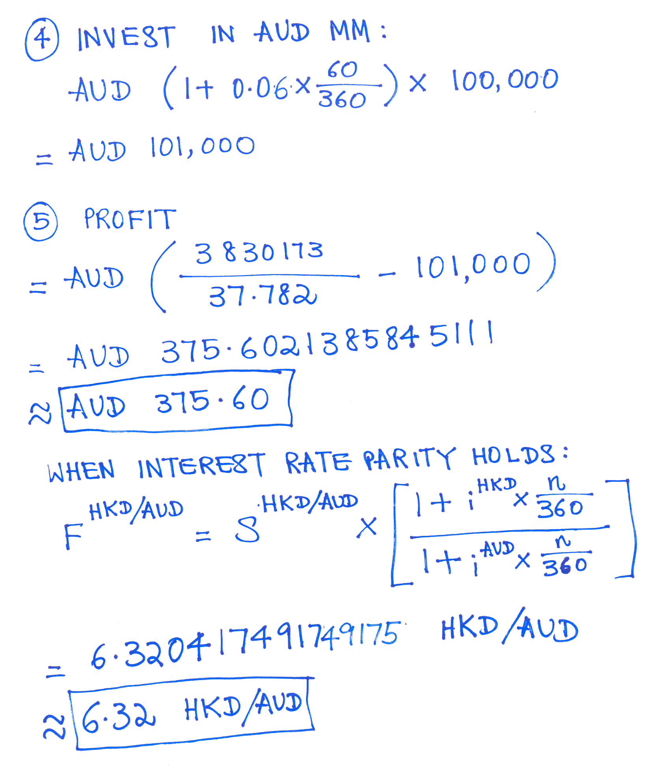

**Practice** (Semester 2 – Mid, 2020)

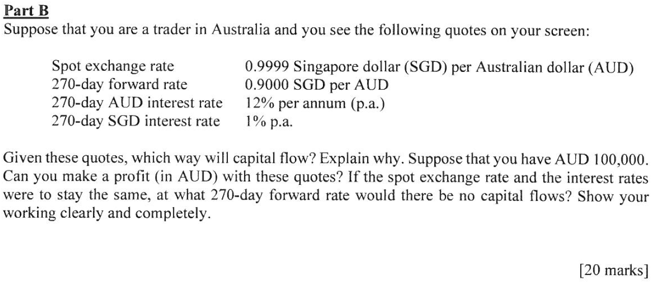

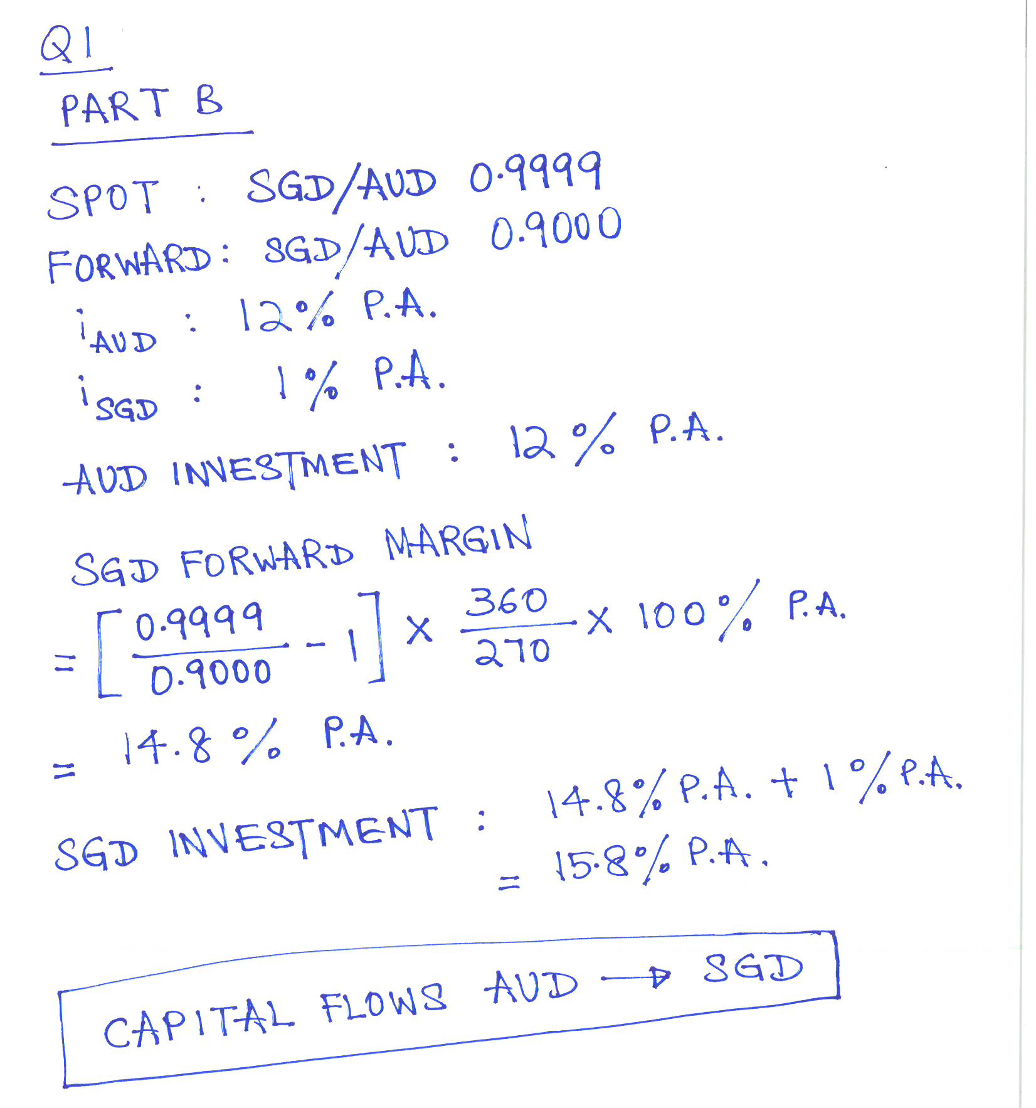

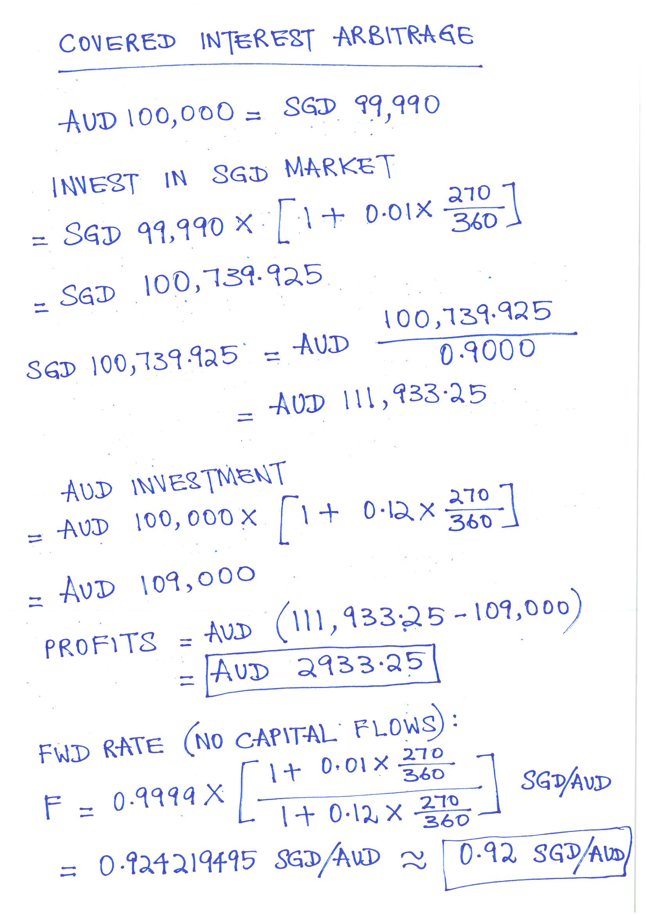

**Practice** (SQ7)

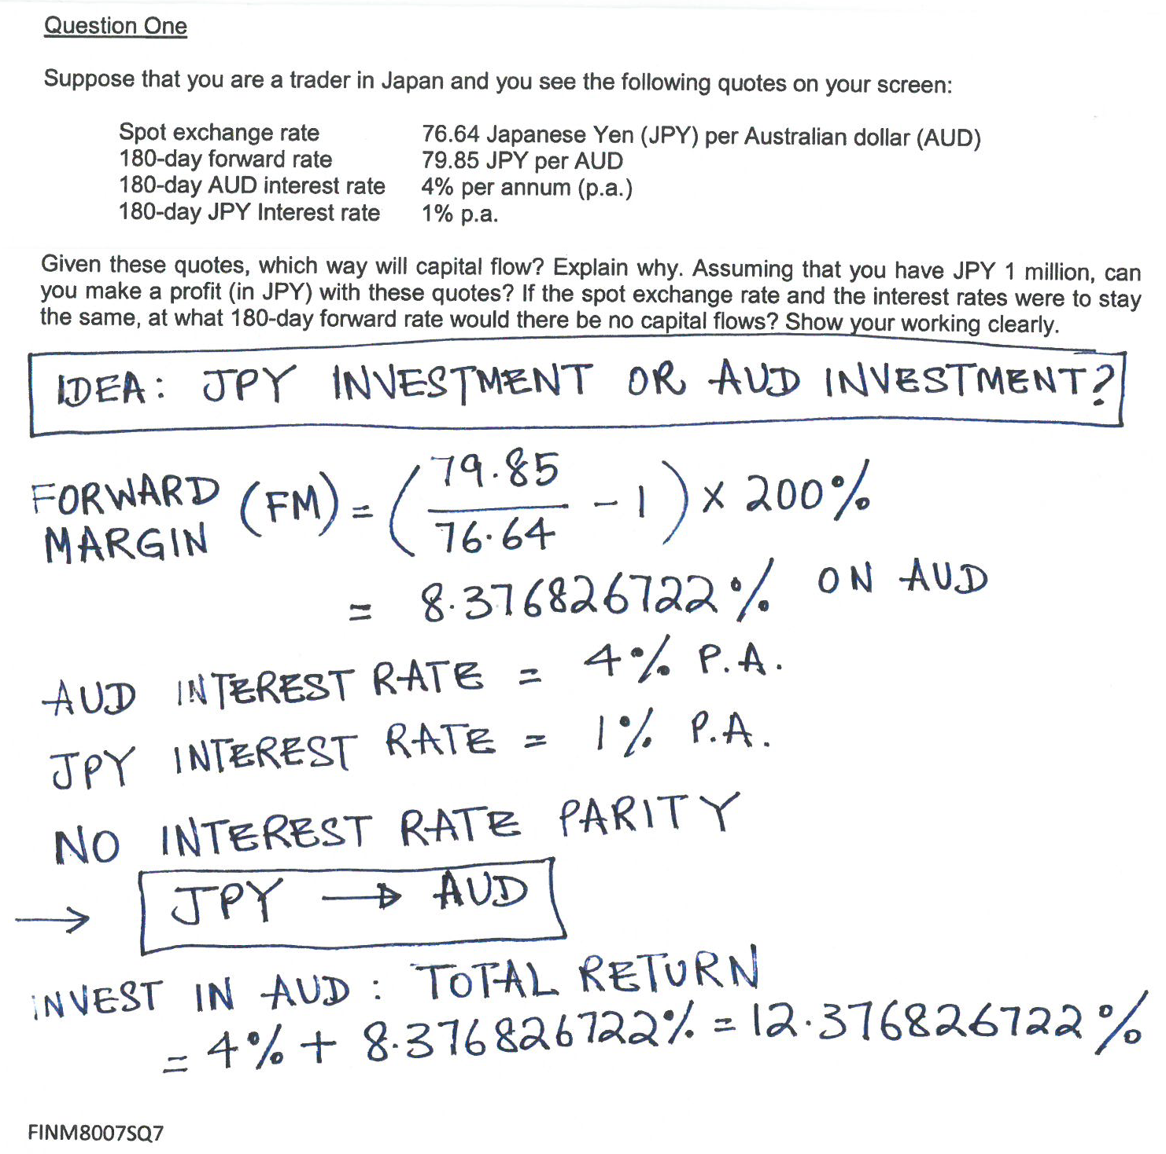

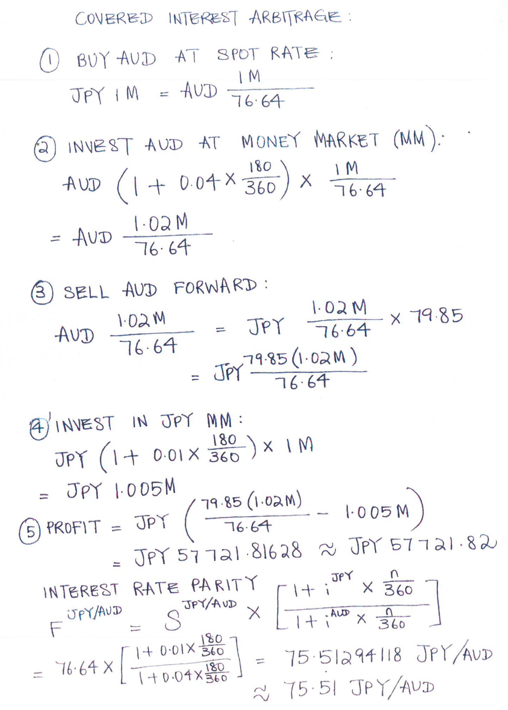

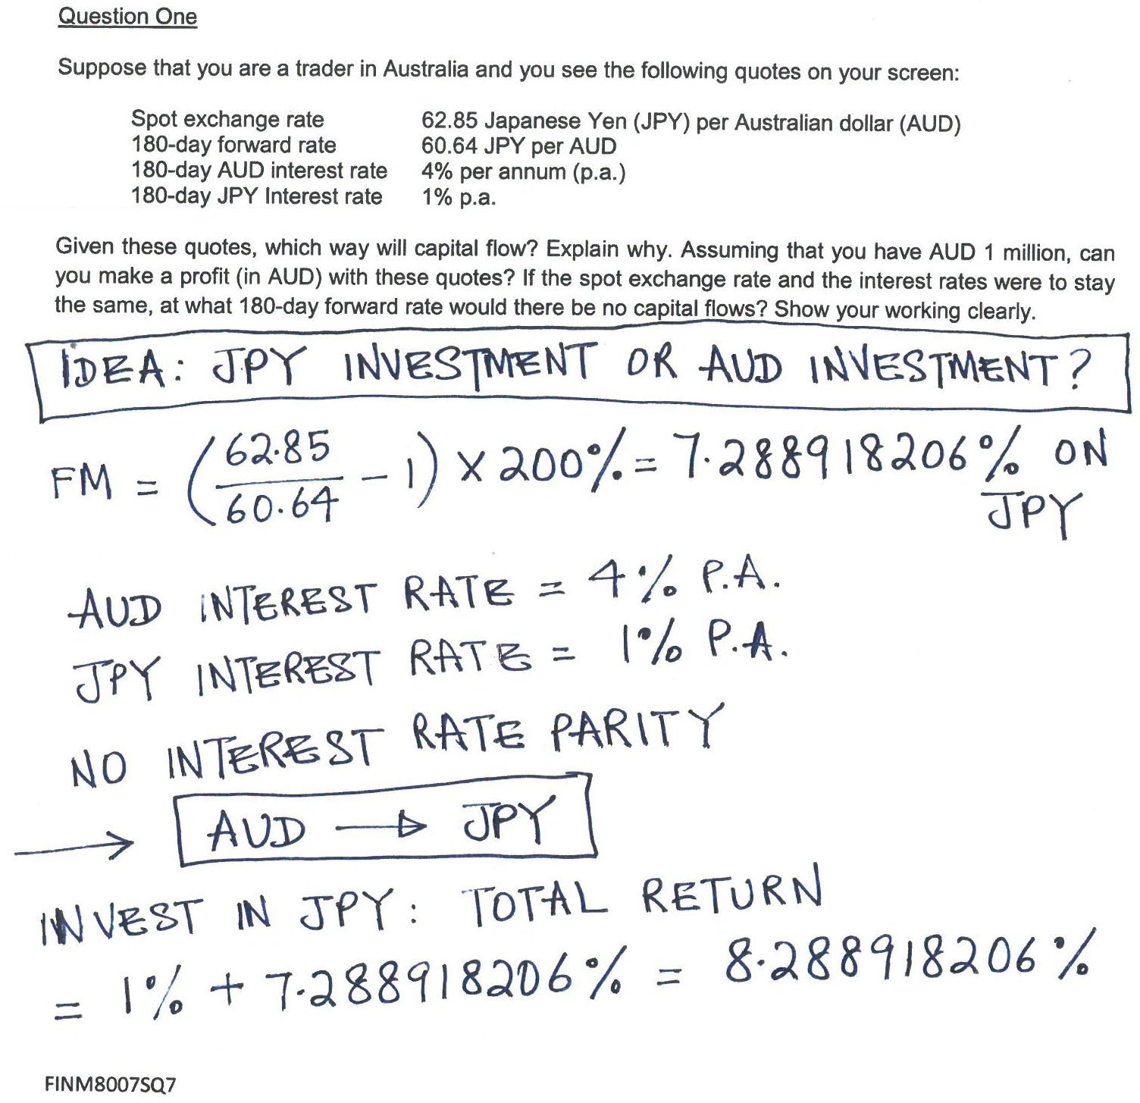

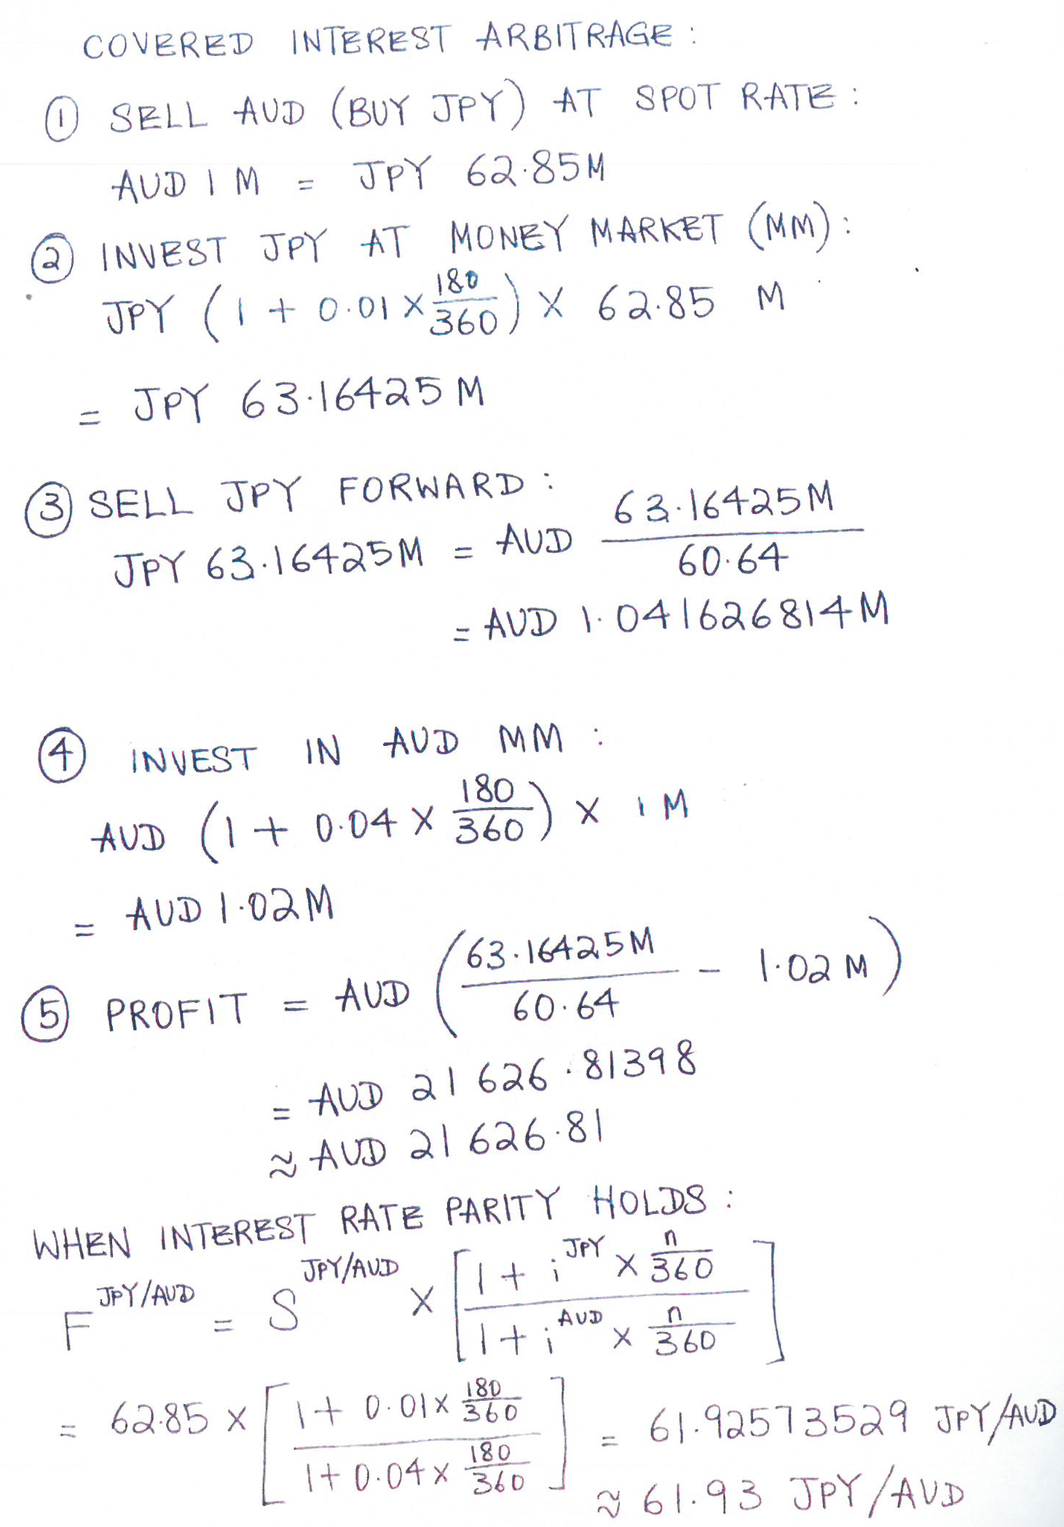

**Practice** (Semester 1 – Review Question, 2021) Question 3: Suppose that you are a trader in Japan and you see the following quotes on your screen:

|  |  |
| --- | --- |
| Spot exchange rate | 86.85 Japanese Yen (JPY) per Australian dollar (AUD) |
| 30-day forward rate | 87.41 JPY per AUD |
| 30-day AUD interest rate | 4% per annum (p.a.) |
| 30-day JPY Interest rate | 1% p.a. |

Assuming that you have JPY 1 million, can you make a profit (in JPY) with these quotes? Show your working clearly.

**Solution**:

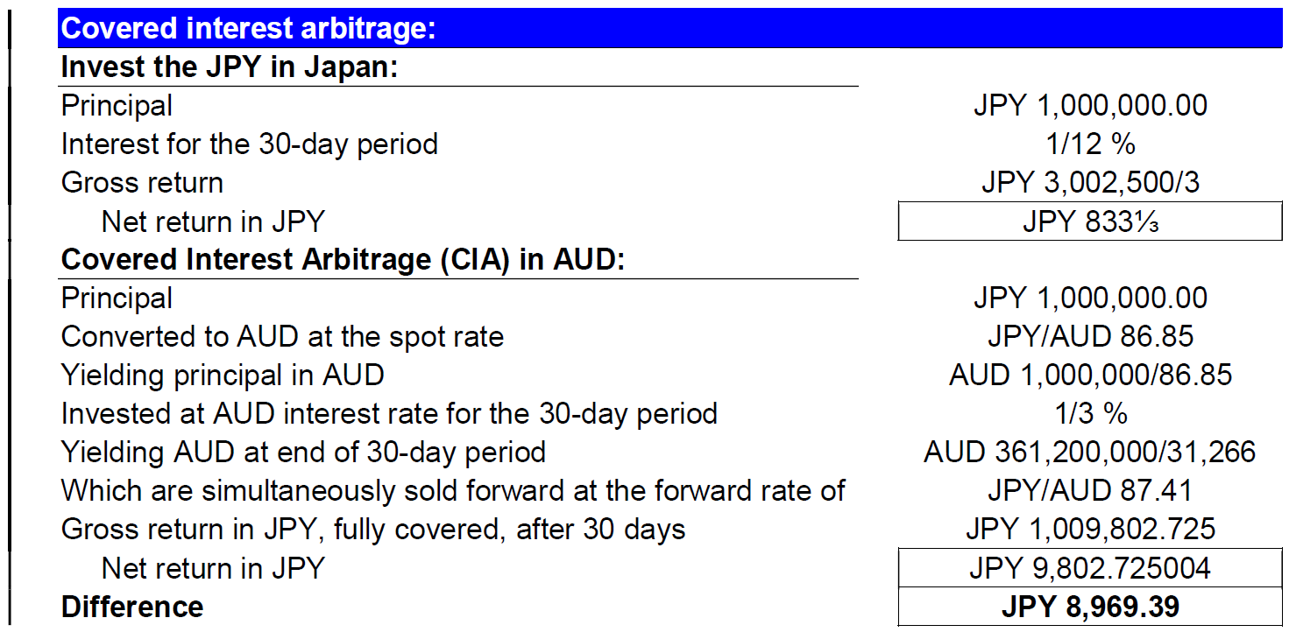

You can make a profit of JPY 8,969.39 from CIA in AUD.

### 2.2 Uncovered Interest Arbitrage

## 3. Foreign Currency Speculation

### 3.1 Speculate in the Spot Market

### 3.2 Speculate in the Forward Market

## 4. Foreign Exchange Swaps